聞くこと　　＜2年＞

　英語のクラスで、真琴（Makoto）さんは、グラフを基に２年生対象のアンケート調査の結果を発表します。それを聞いたあと、質問が放送されます。質問の答えとして最も適切なものを、下の１から４までの中から１つ選びなさい。

＜School Lunch Research＞

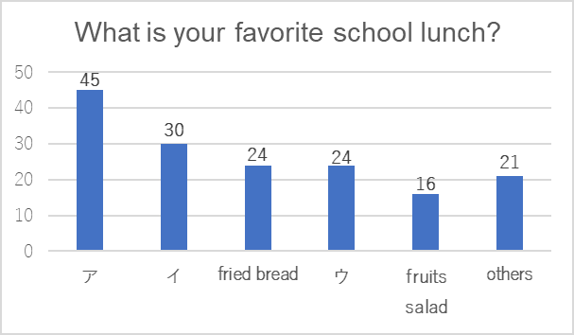

人

【figure 1】 【figure 2】

１　 ramen　　　２　 fried chicken　　　３　curry and rice　　４　 yakisoba

**（スクリプト）**

Hello, everyone. I’m Makoto. I asked 2nd grade students about school lunch.

Please look at figure 1. According to my research, eighty-three percent of students like school lunch.

Next, look at figure 2, please. As for the favorite menu of school lunch, forty-five students like curry and rice the best. Thirty of them like ramen the best. And fried bread got the same number as fried chicken. Sixteen like fruits salad the best. On the other hand, twenty-one like other kinds, such as yakisoba, nikujaga, pasta, and so on.

As a result of my research, I found that curry and rice is the most popular in the 2nd grade students. Enjoy your school lunch! 　(112 words)

Question: From the figure 2, what doesイ show?

出題の趣旨：日常的な話題について、目的に応じて英語を聞き、必要な情報を聞き取ることができるかどうかをみる.