２学年 聞くこと に関する問題
【聞くこと】
ア はっきりと話されれば、日常的な話題について必要な情報を聞き取ることができるようにする。
ウ はっきりと話されれば、社会的な話題について、短い説明の要点を捉えることができるようにする。
【書くこと】
ウ 社会的な話題に関して聞いたり読んだりしたことについて、考えたことや感じたこと、その理由などを、簡単な語句や文を用いて話すことができるようにする。

〇環境問題に関する英文を授業で読み、環境に関する語句がある程度理解できている状況と設定しての出題

【問】
あなたのクラスにイギリスから来たALTのマイク先生と、週末のできごとについてクラスで話しているところです。対話を聞き、以下の問いに答えなさい。

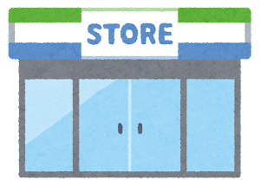
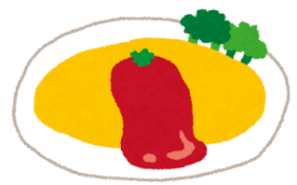
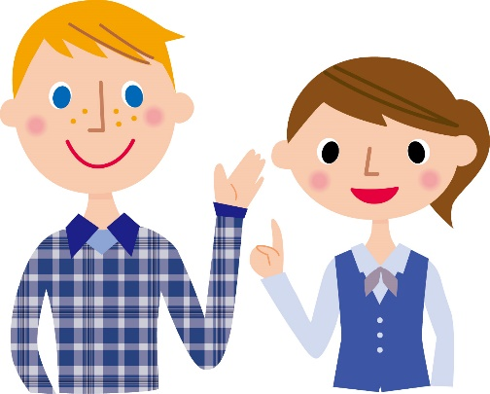

（１）対話の内容に合うものを下のア～エの中からひとつ選びなさい。
ア Mike and Yuki went out for lunch together this weekend.
イ Yuki was surprised to know she had to pay for her plastic folk.
ウ In Mike’s country, people started paying for plastic products from October.
エ Mike thinks that people should stop using plastic products to save money.

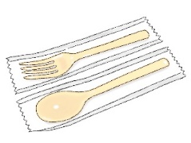
(2) 対話の後、あなたはマイク先生から次のように質問をされました。あなたはどう答えますか。２文以上かつ１５語以上の英文で答えなさい。
Do you want to pay for plastic products, such as spoons and folks at convenience stores? And why do you think so? Please tell me.

【対話スクリプト】

Yuki: Hi, Mike! How was your weekend?
Mike: Oh, Yuki. It was really nice. I went to a park and enjoyed a beautiful scenery.
There were a lot of beautiful flowers. The weather was also nice, so I took boxed lunch and ate it outside. I ate omelete rice. Eating favorite food outside is great!!
Did you go anywhere?
Yuki: Yes, I did. I also went out to a zoo and ate lunch outside. It was a good day for picnic.
So I bought gapao rice at a convenience store near the zoo. Did you also buy your lunch at a convenience store?
Mike: No. I made it by myself. I love cooking. Why did you ask the question?
Yuki: If you bought lunch at a convenience store, I want to ask about a plastic folk.
Mike: Plastic folk? What do you mean?
Yuki: I had to pay for my plastic folk!! I was really surprised.
Mike: Pay for plastic folks? I think it’s good. You shouldn’t use plastic to save the earth and animals. If people have to pay for plastic products, more people will try to stop using them.
In my country, we will start a rule to stop using plastic products like folks, spoons, cups trays and so on at stores. I think we should reuse things more. We will start the rule in October. After that, stores can’t give plastic products to serve food to customers.
Yuki: You can’t use plastic spoons anymore in your country? Then how can you eat food like spaghetti?
Mike: Some stores start selling dishes at the store which can use many times.
I think we must do something for the better future for us, animals and the earth.

【正答】
(1) イ
（２）(例) No, I don’t. It is because I want to save the earth. I will use my folk and spoon.
(例) Yes, I do. It is because I don’t have my folk when I buy food at convenience stores.

